Bannari Amman Institute of Technology

Sathyamangalam -638 401, Erode District, Tamil Nadu

DEPARTMENT OF COMPUTER SCIENCE AND ENGINEERING.

WEB PHISHING DETECTION

(**ASSIGNMENT 3)**

DATE : 08.10.2022

PROBLEM: TO ANSWER THE QUESTIONS FOR THE ANSWERS

NAME: SABARISSHAN G K

OUTPUT: SCREENSHOTS:

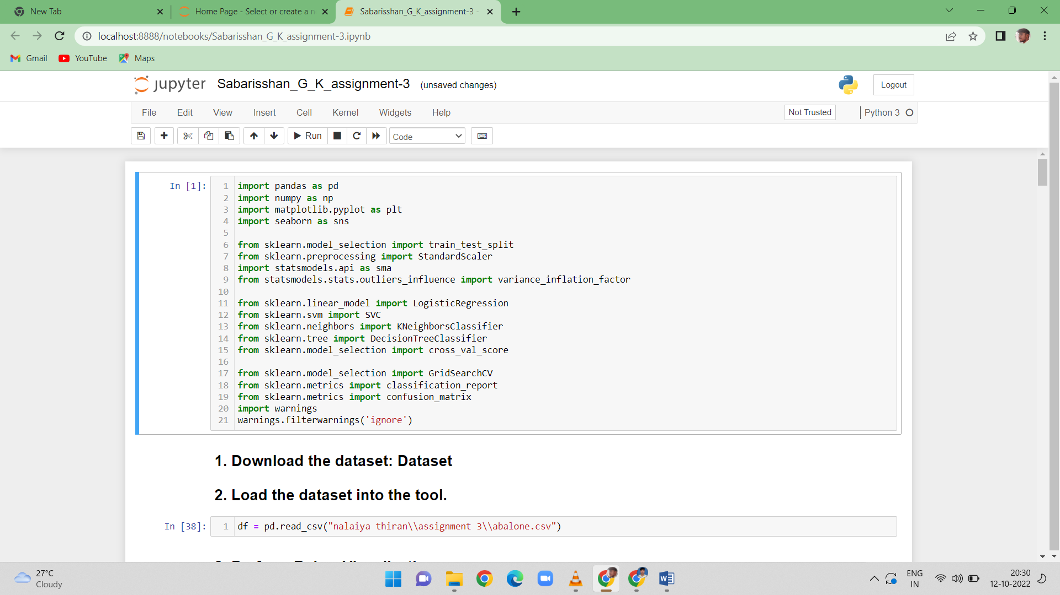

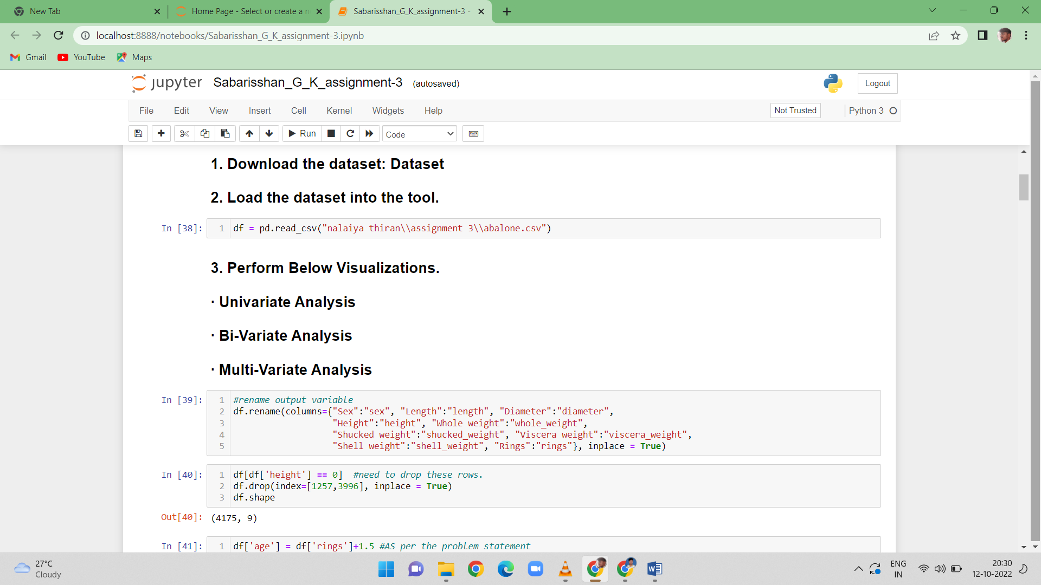

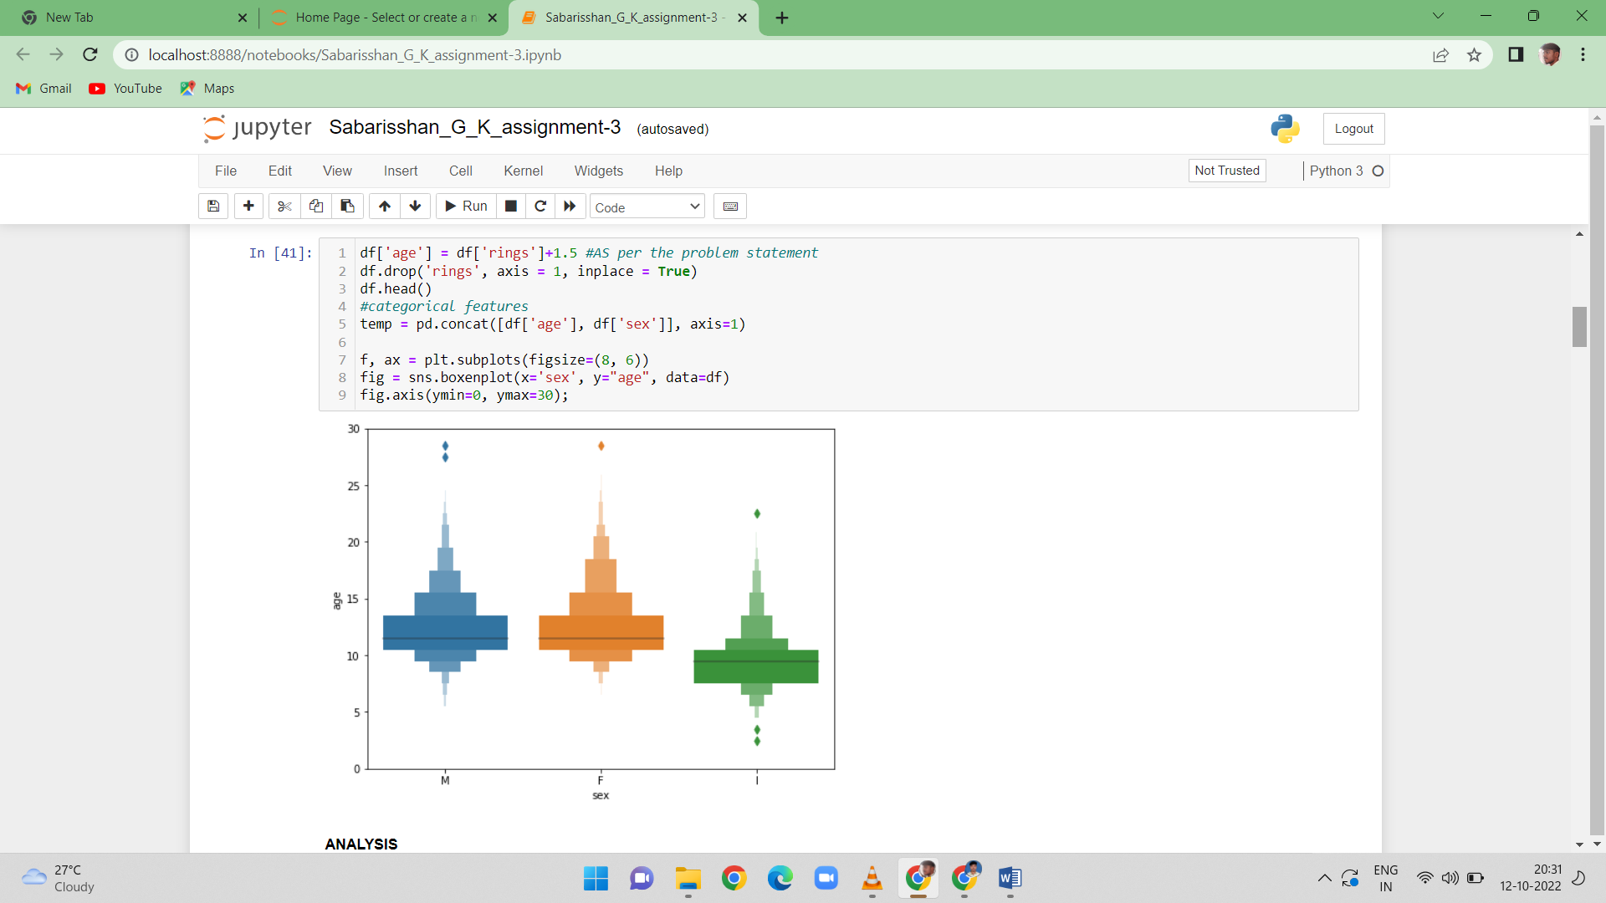

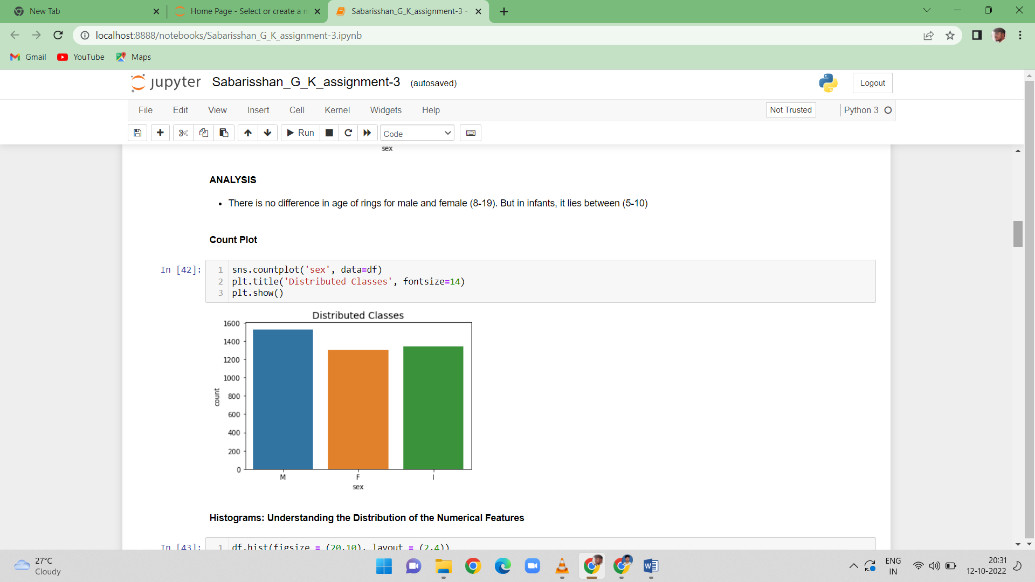

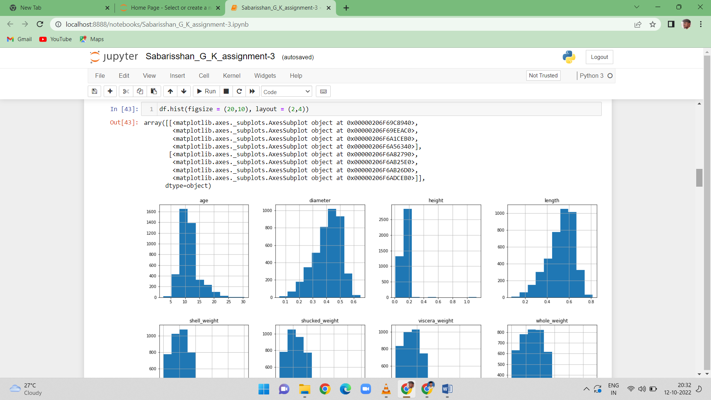

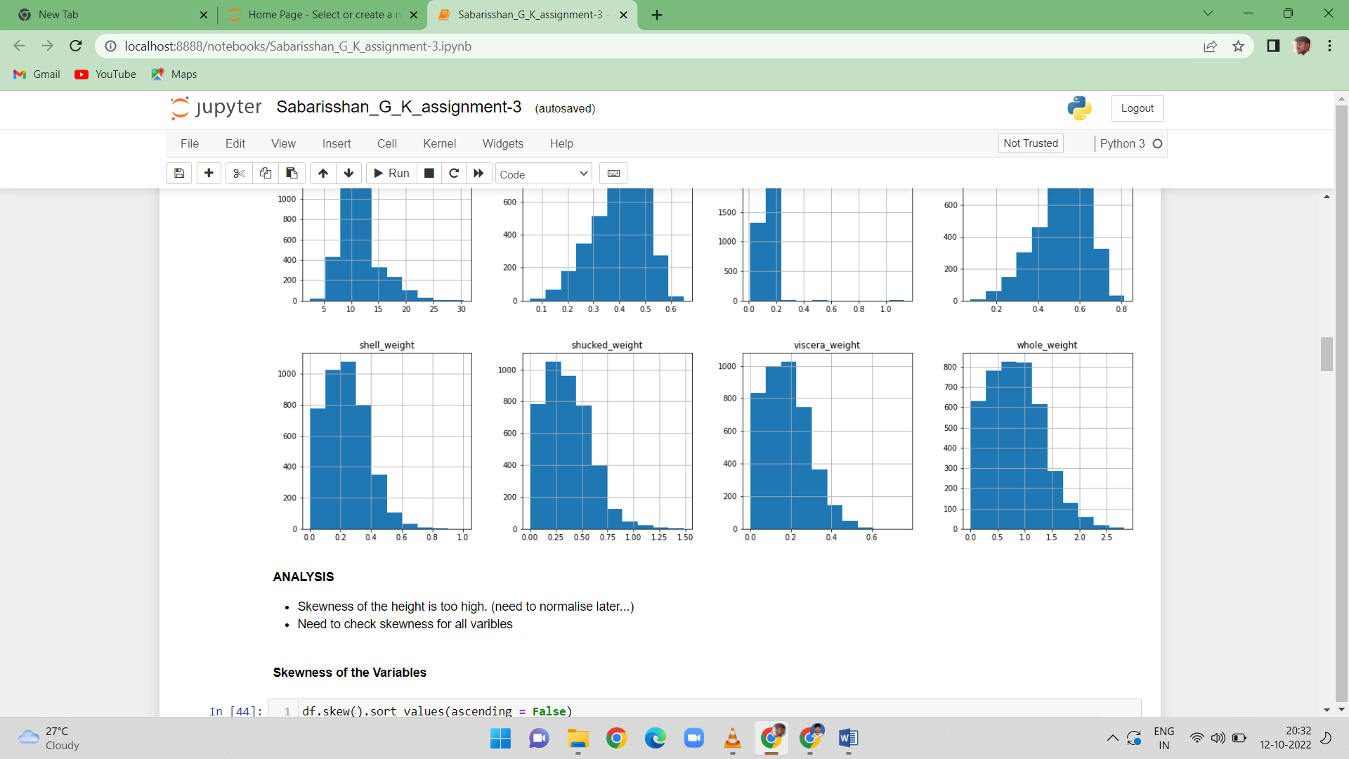

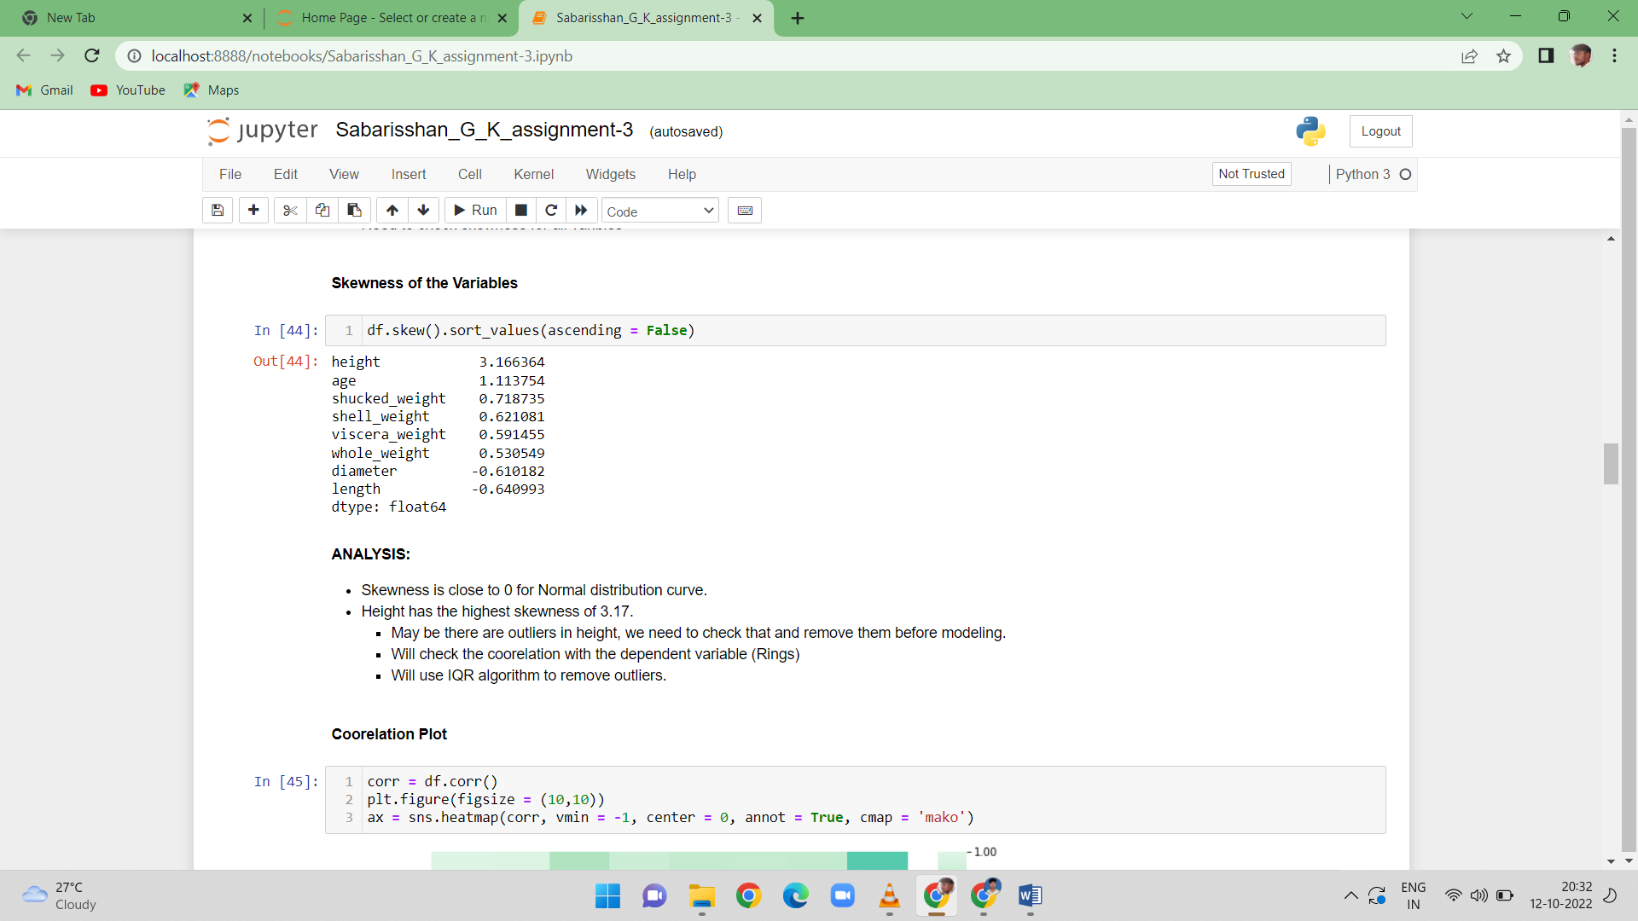

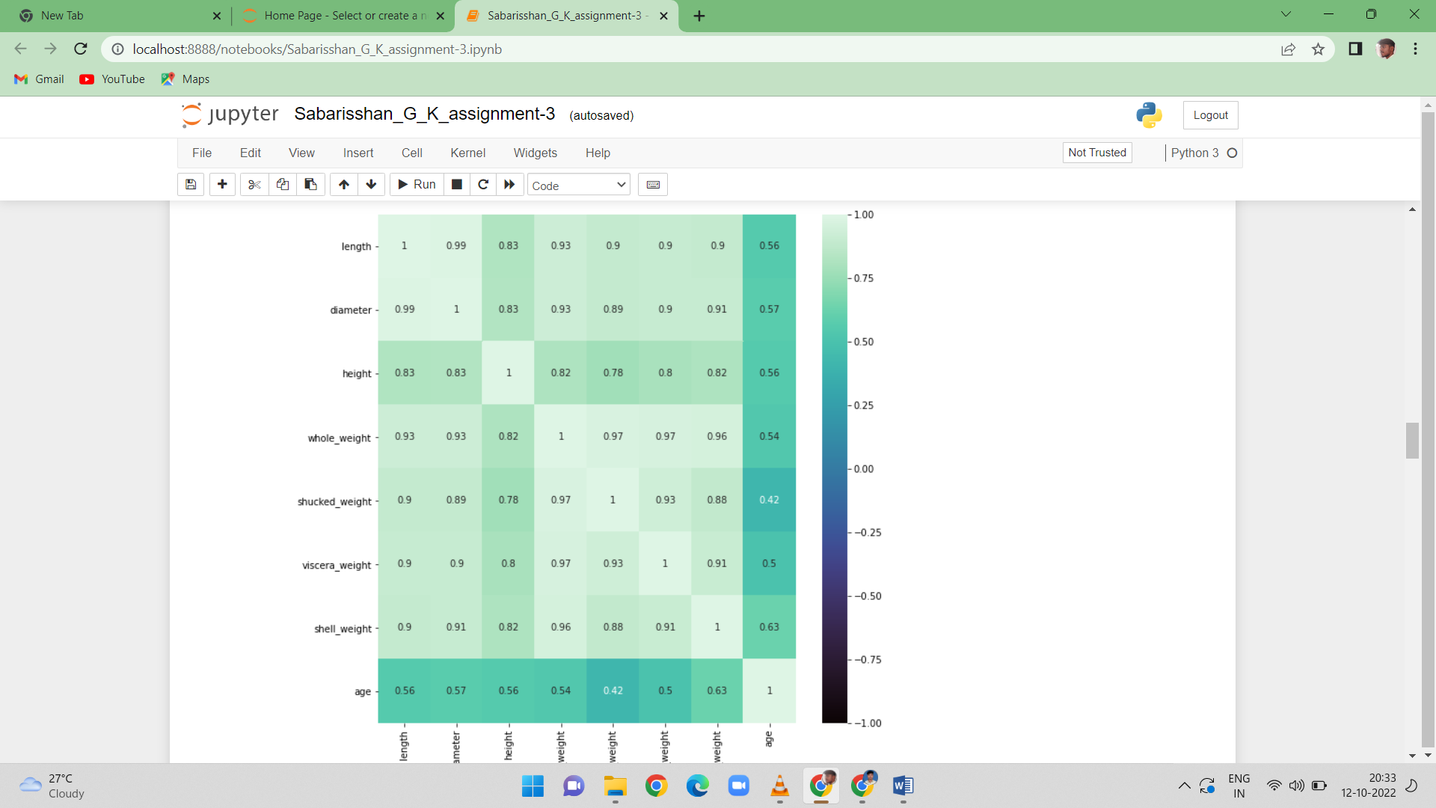

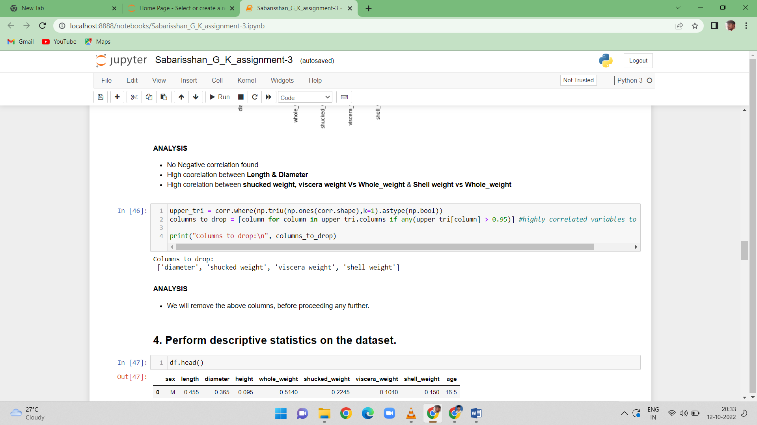

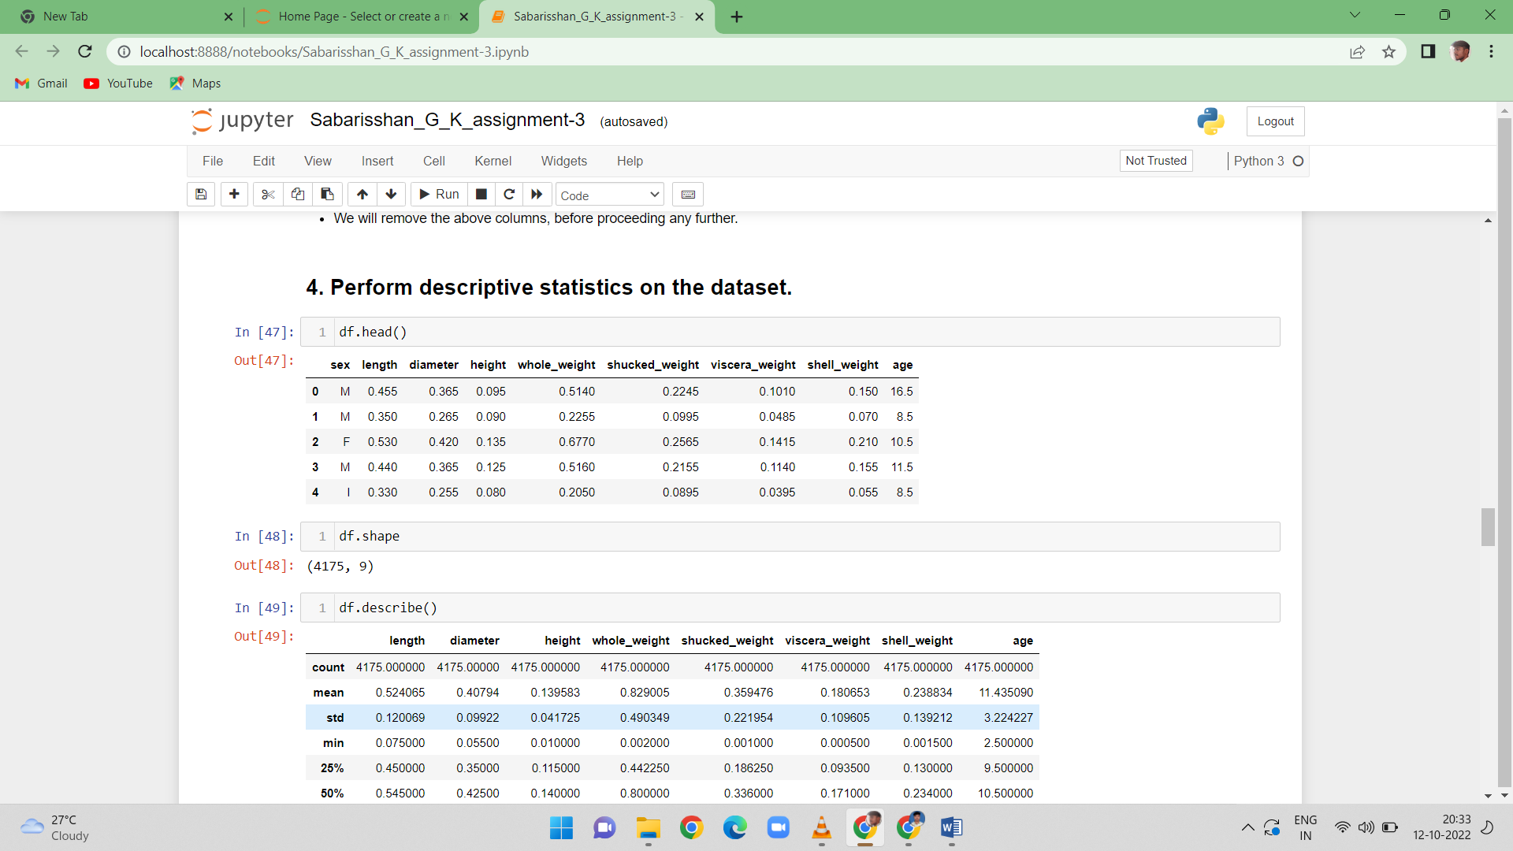

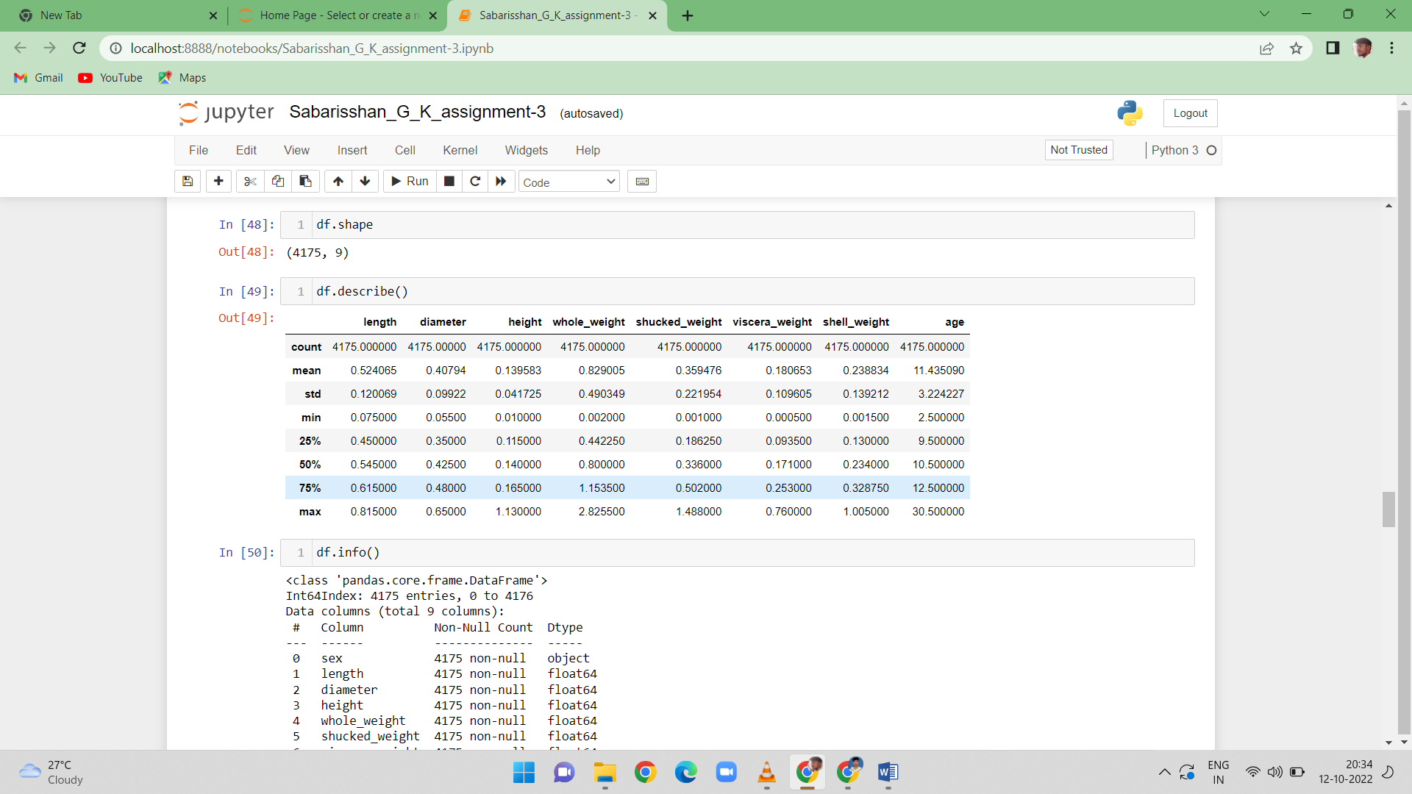

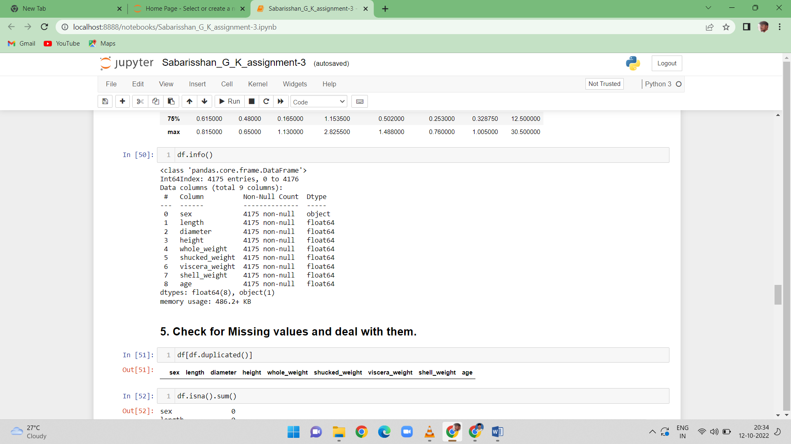

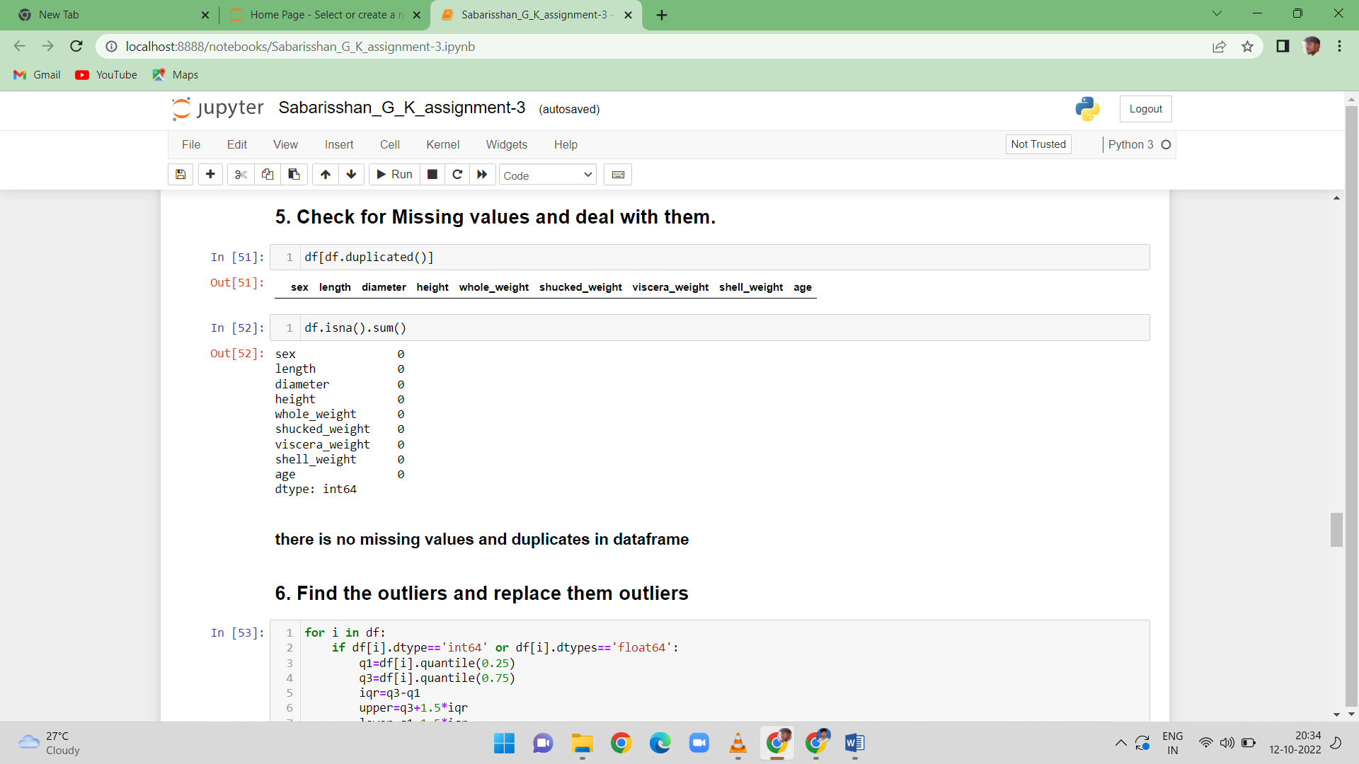

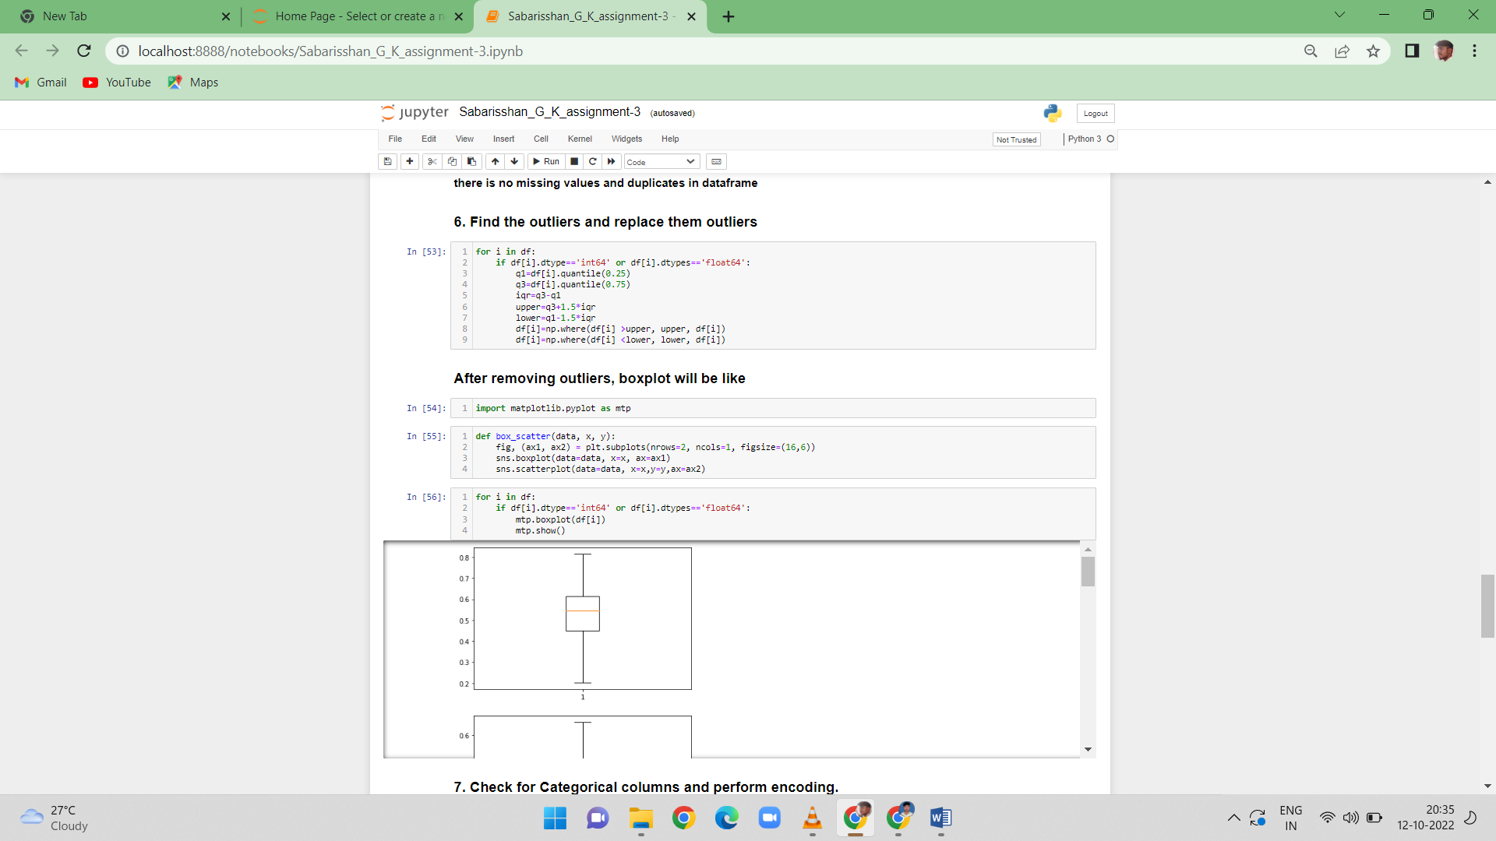

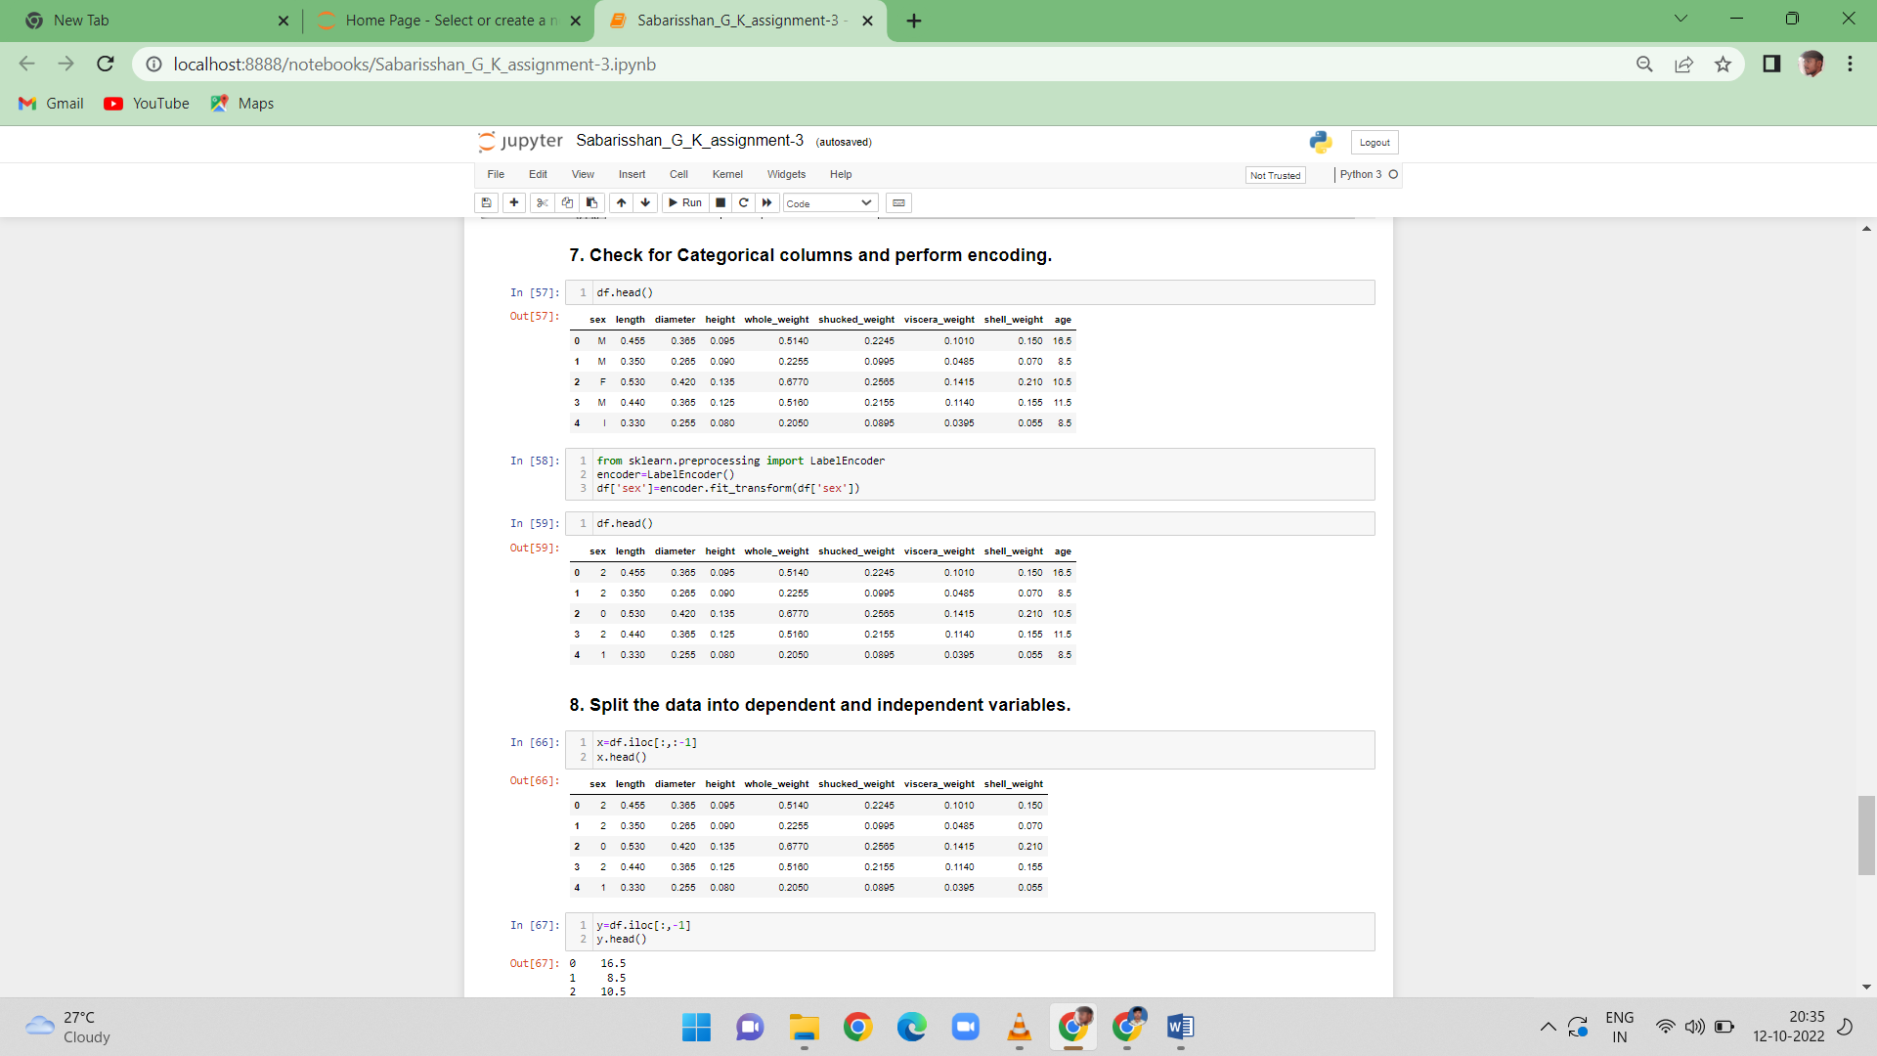

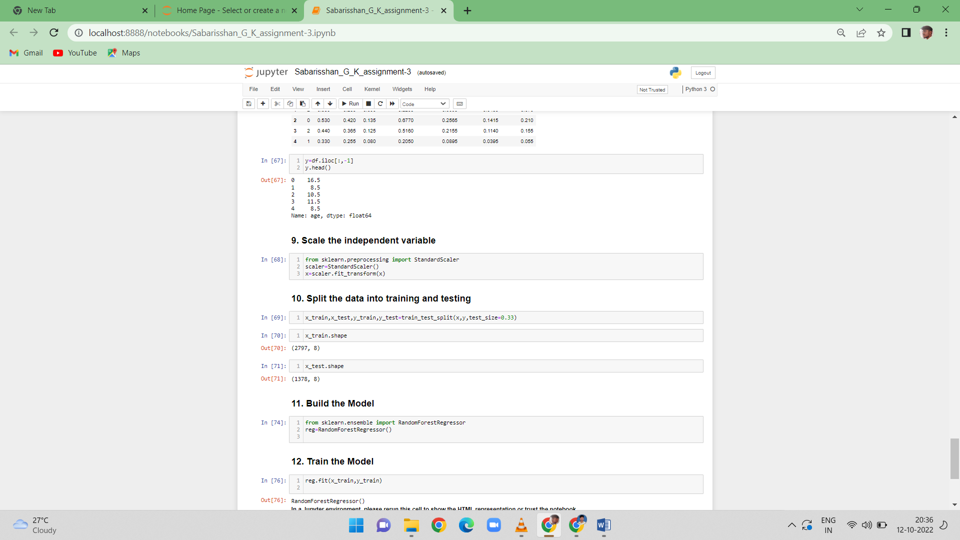

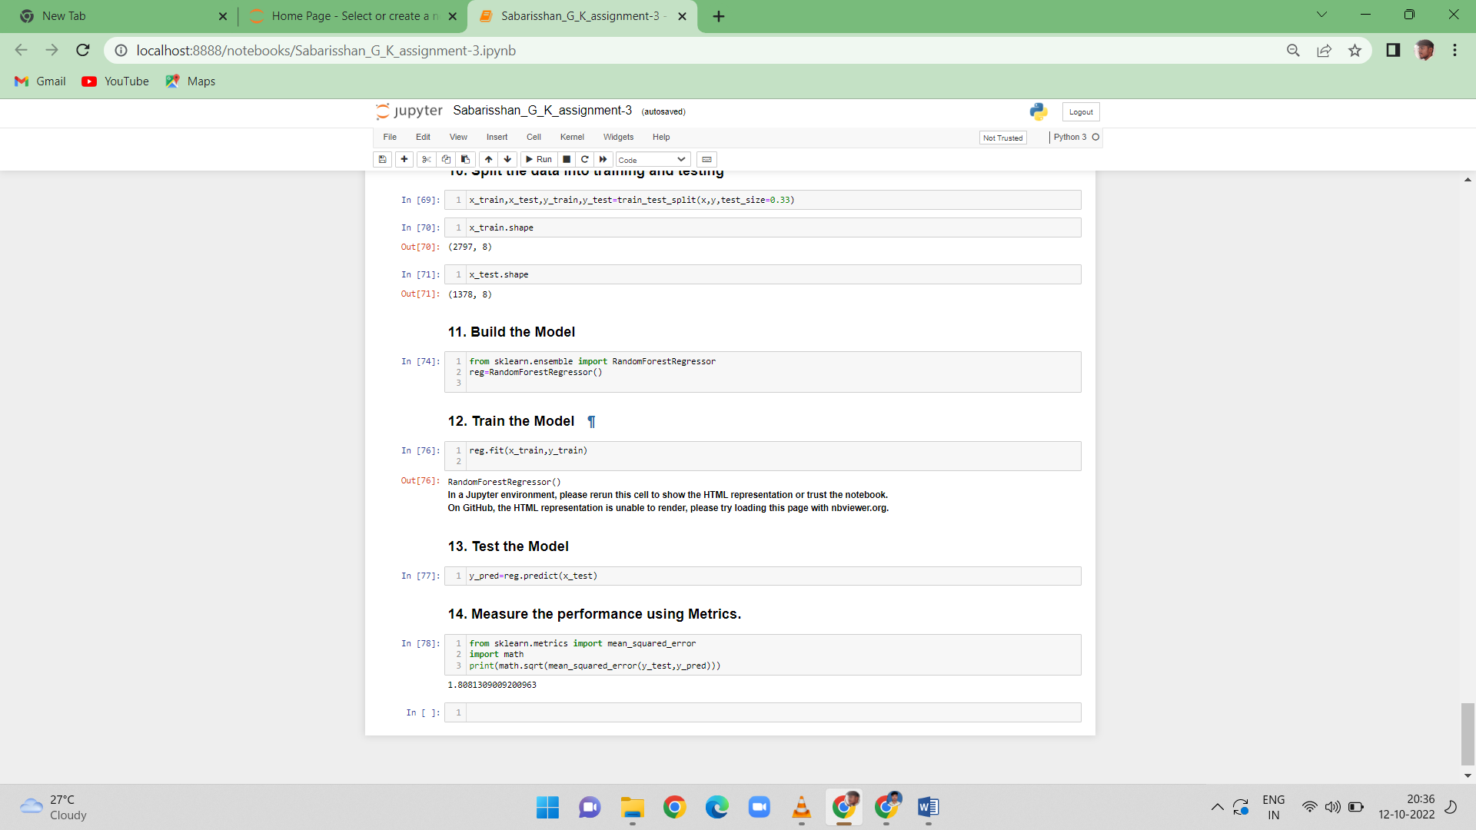

******************************THANKING YOU***********************************